**SELL**

**TATA MOTORS LTD.**

**Current Market Price 122.05 (12th August, 2019)**



**Key Indicators:**

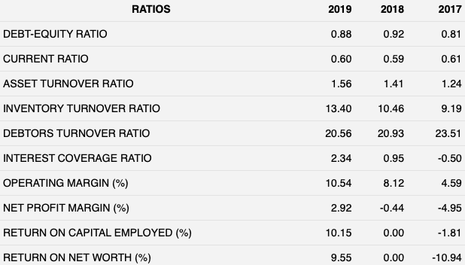

**About the Company:**

Tata Motors was established in 1945 under the Tata Group. It is among the world’s leading manufacturers of automobiles with around 81,090 employee strength. It was the market leader in commercial vehicles segment with about 44 per cent market share in FY18. It is present in segments like cars and utility vehicles, trucks and buses, and Defence.



**Conclusion:**

**Due to the stock being overvalued as per our valuation, we have a sell recommendation for the stock of Tata Motors Ltd.**

**Economy Overview**

Due to the decline in the growth of the GDP and the slowdown in the economy, the automobile industry is adversely affected. The sales in the automobile industry is declining. High costs of borrowing and elevated consumer price inflation adversely affected household consumer sentiment and spending. On the other hand, slowdown in GDP growth has been due to decline in both consumption and investment growth. Investments were stalled because of high interest rates, poor demand conditions, and regulatory issues.

**Industry Overview:**

The Indian automobile industry, the world’s fourth-largest, has embraced a slowdown after a near-decade of high growth. On May 13, the Society of Indian Automobile Manufacturers (SIAM) announced a 21 percent decline in vehicle sales for May, the lowest in nearly eight years. Auto industry has been moving towards inventory correction. Higher insurance cost on the new vehicles because of the revised regulations by Irdai and lower discretionary spends due to poor sentiments are major reasons in driving down the sales.

**Key Highlights:**

The sales of the company in Q1 of FY 19 has declined as compared to that of Q1 of the previous year. The JLR revenue, one of the main sources of revenue for the company was down by 6.7%

**Recent Trend:**

